**SoloLearn 5.3 Pro Exercise**

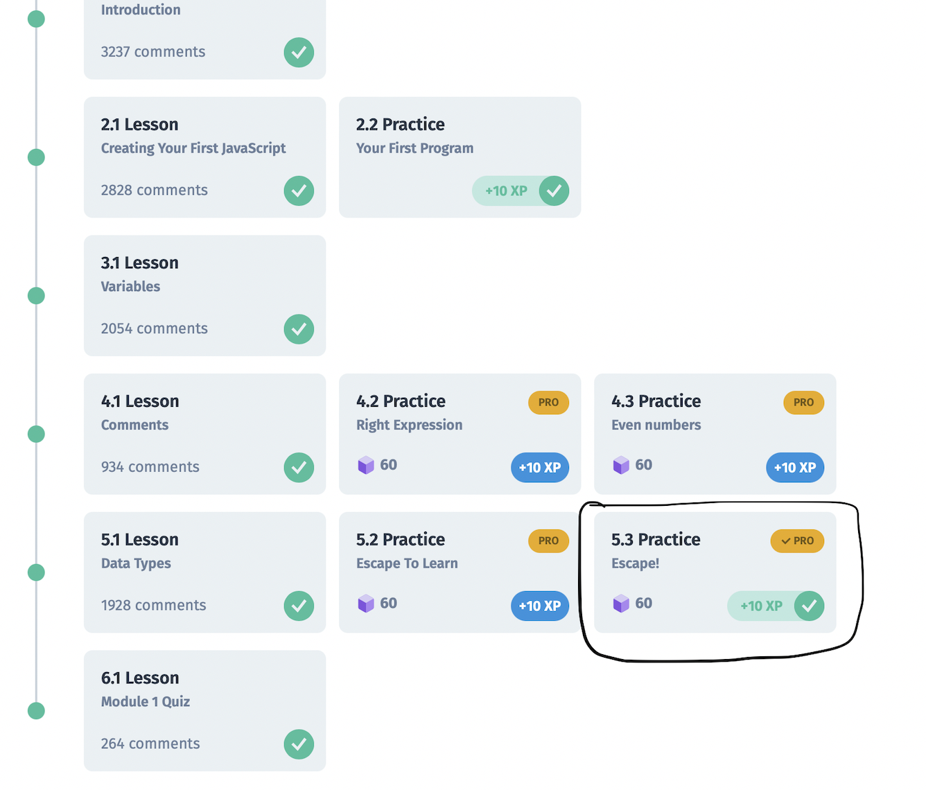

**Explanation:**

Problem:

**console.log(“Quote of the day: “Less is more”.”)**

Solution:

**console.log(“Quote of the day: \“Less is more\”. ”)**

Escape sequence is used to put non-printable characters into character and string literals. It is followed by ( \ ) backslash. For example here; we have to print double-quotation(“) inside a string with double-quotation; implementation of escape sequence becomes necessary. We can put double-quotation using (/”) backslash followed by double-quotation inside a string having double-quotation..